

Product Catalog System

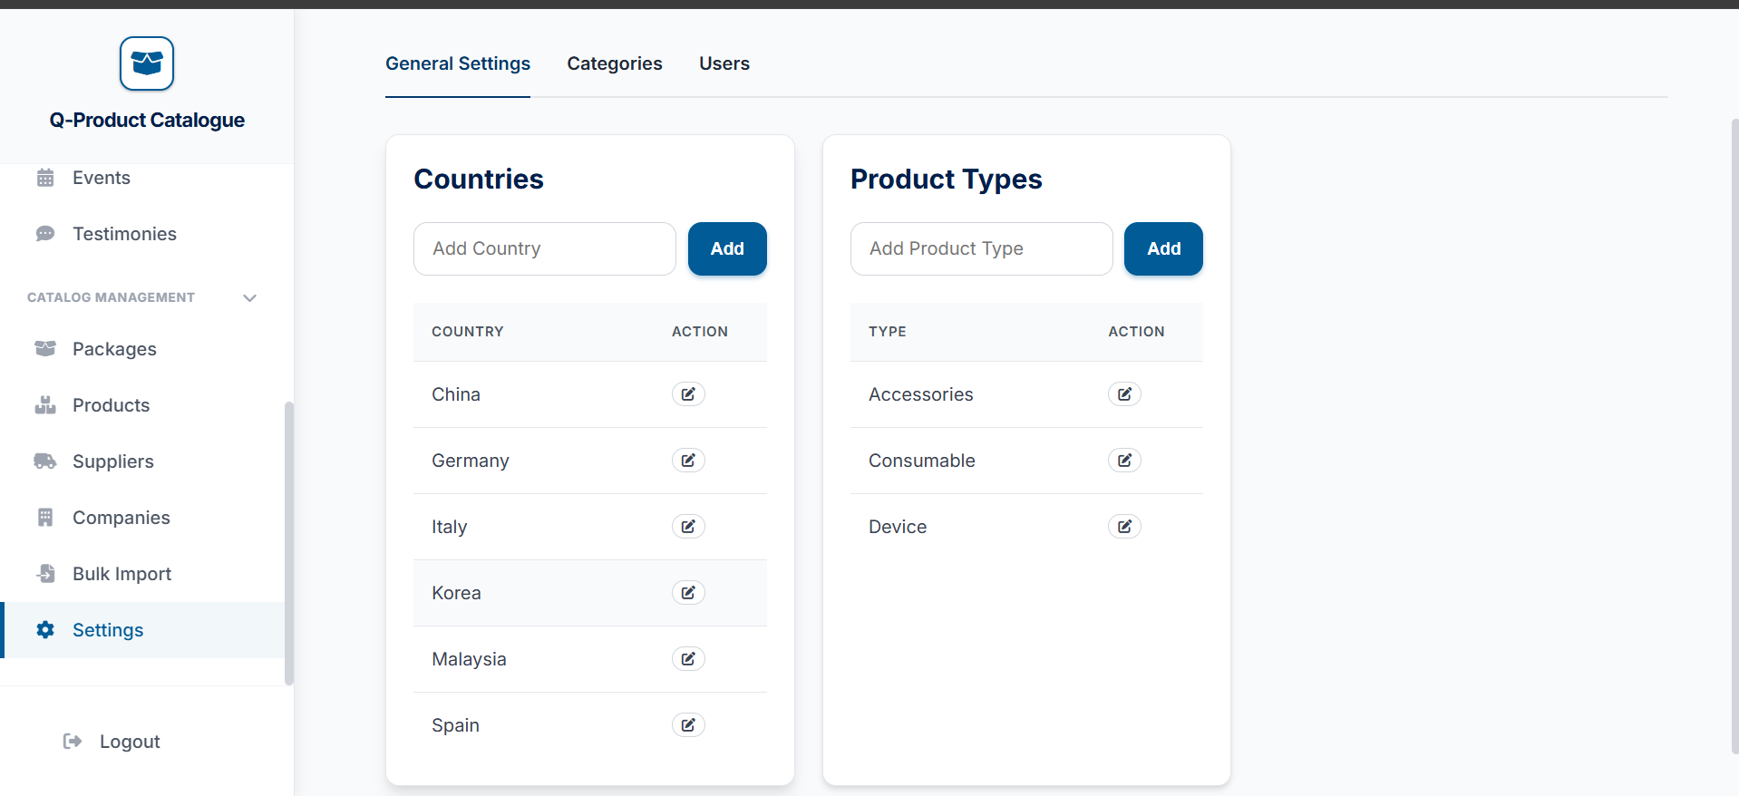
How to add a product type
Go to the very bottom of the side bar to the Settings tab


To enter product types in bulk you can follow the following steps:
Enter the product type you want here

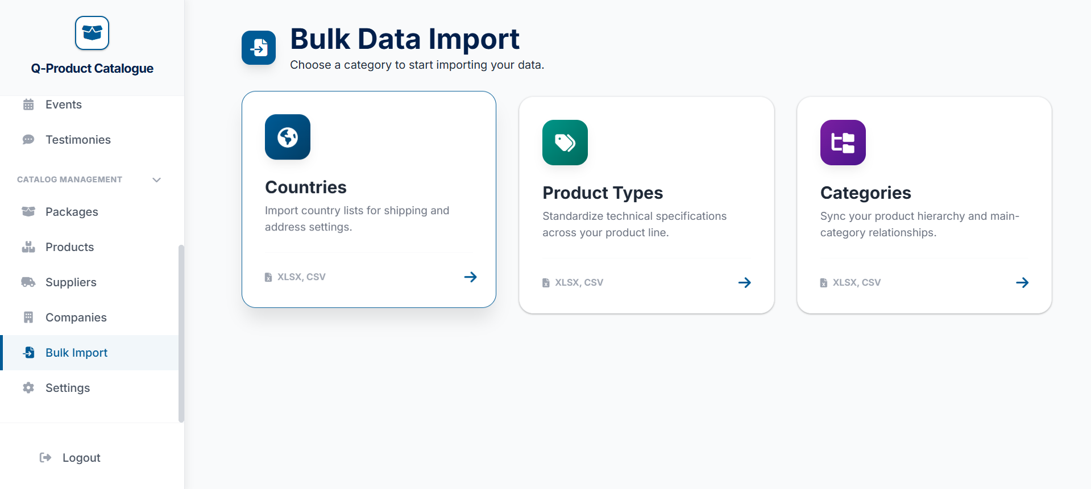


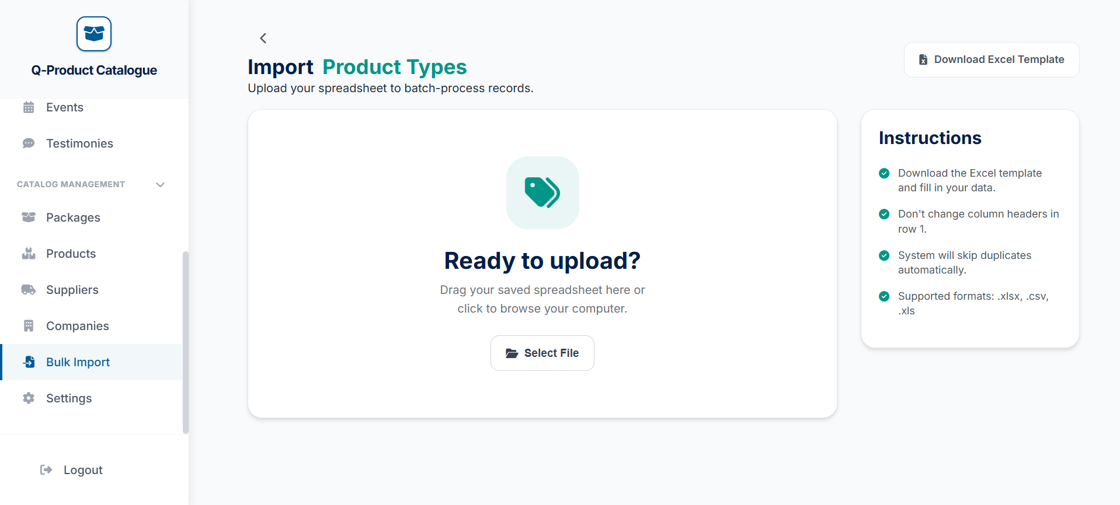
Then click on the product types option
Then upload the filled template in here
Just download excel template and fill up the product types in that template
Go to the Bulk import tab
Enter the country you want here
Enter the country you want here

